RC Car

Data Acquisition Project

Components:

Car:  
3D printed frame  
4 DC motors with reductors  
4 AA batteries with battery holder  
L298N dual motor driver  
Raspberry Pi 3 Model B  
Portable power bank

Circuit scheme:

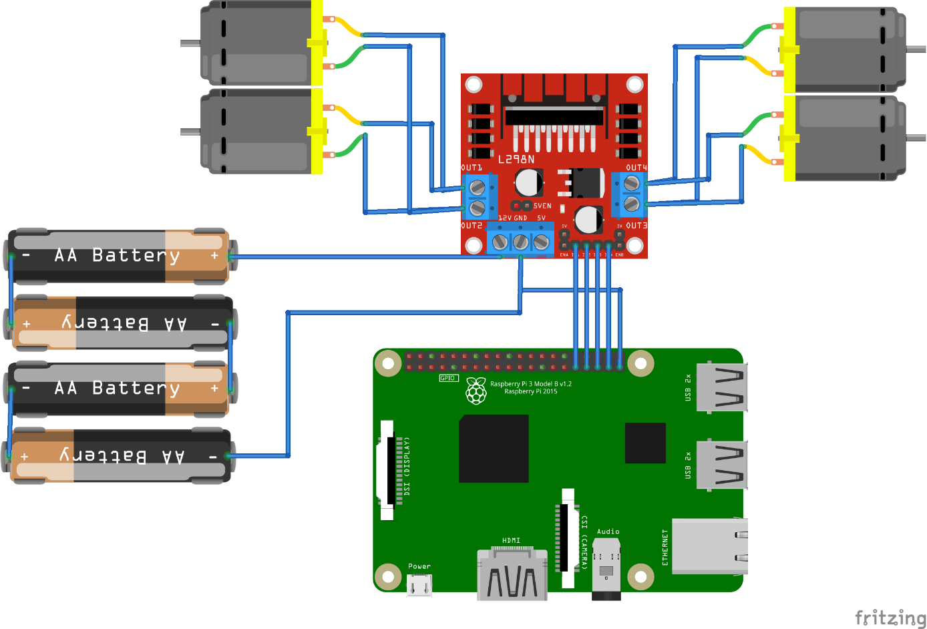

Actual RC Car:  
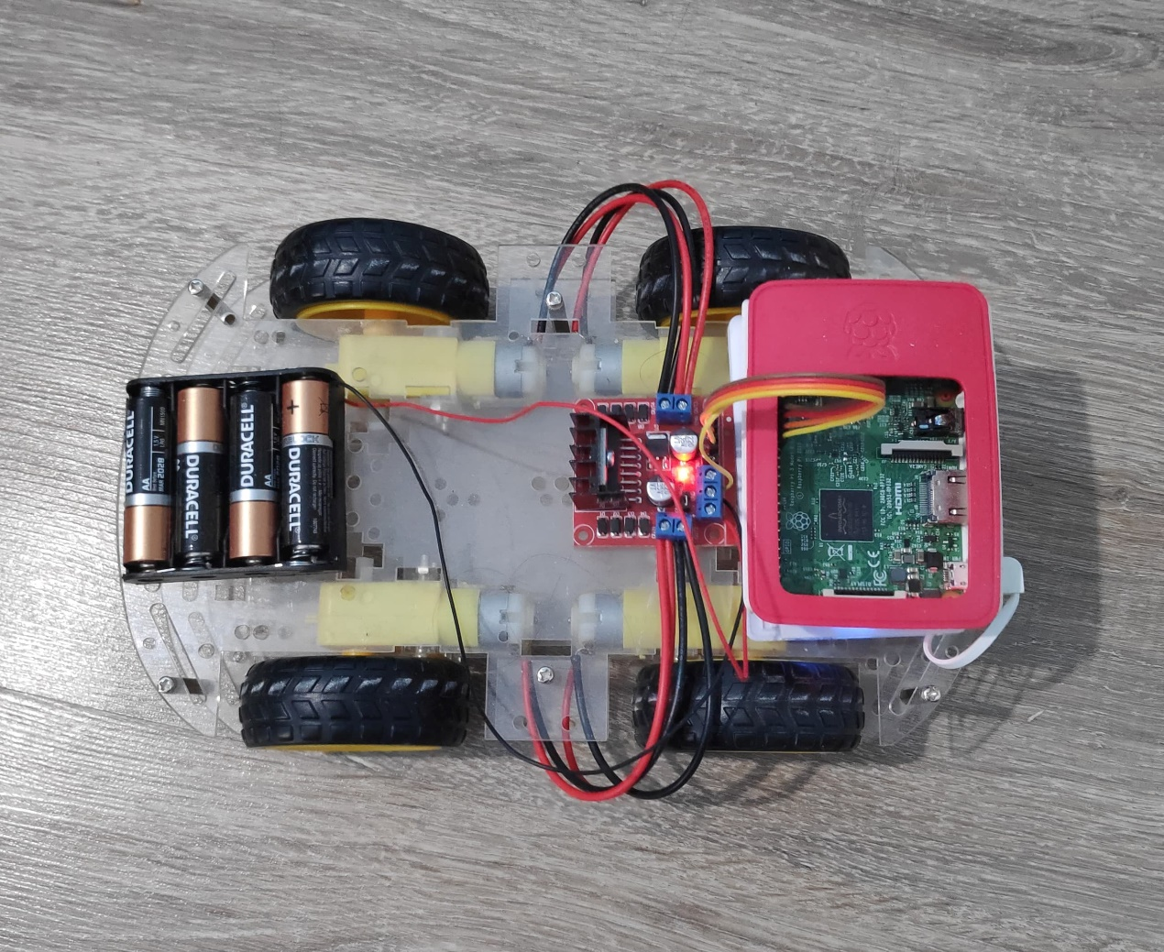

Remote:  
LabView Application - Contains controls for speed and direction

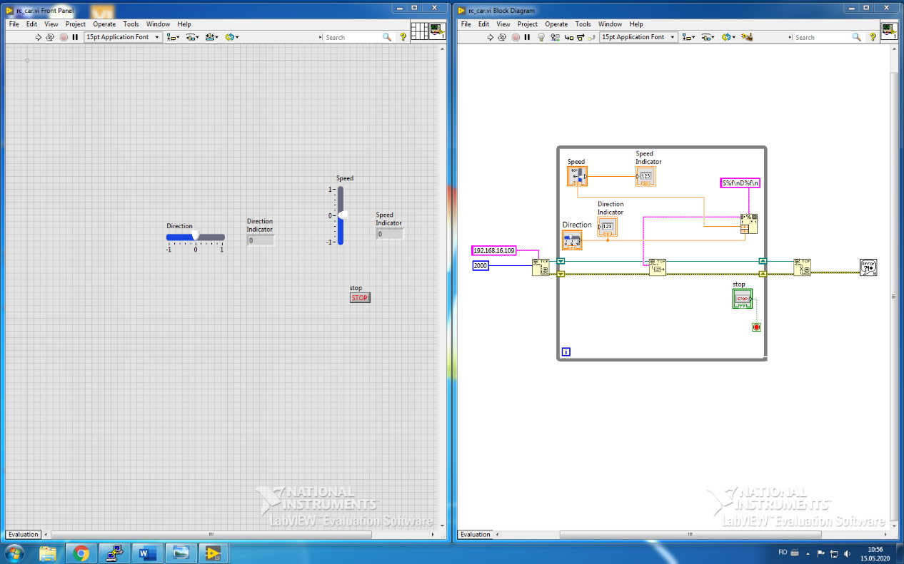

Application Flow:

LabView will be used as a TCP client that sends messages to the server containing the speed and direction wanted by using the following format:

S<speed>  
D<direction>

Where speed and direction are floating point numbers, betweeen -1 and 1

Raspberry Pi will be used as a TCP server that receives messages from the server containing messages about the wanted speed and direction and updates the pwm dutycycle accordingly.

Mentions:

Motors are connected in parallel, so we will control the car as having left motors and right motors.